
Spring Brings New Life
In his great mercy he has given us new birth into a living hope through the resurrection of Jesus Christ from the dead. {1 Peter 1:3 NIV}
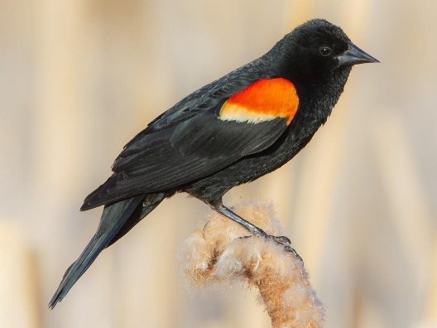
Spring is a time of rebirth.
An Amish kid once told me he knows spring has arrived when the red-winged blackbirds return. Each year, around the end of February, I start scanning the roadside for the miniature sentinels as I drive. I usually spot them soaking up the sun in the early morning hours.
After a particularly cold winter, I spotted a red-winged blackbird perched atop a small brush-like tree as I was on my way to the church. The next morning, I was even more happy to see not one but many red-winged blackbirds stationed every few hundred yards like little soldiers at their post. I knew winter was on its way out and spring was just around the corner.
I like spring because it brings new life. Daffodils and crocuses emerge through cold, hard ground—splattering hues of yellow, purple, and pink against the dingy remains of winter. Colorful buds burst open on grayed tree limbs, clothing them in knobby splendor. Twittering bird choruses fill the air as they reunite after venturing north to their summer homes. Raccoons and skunks forage for food after waking from their long winter naps.
Spring is also the time to celebrate Easter. Easter is a celebration of the death, burial, and resurrection of our Lord and Savior Jesus Christ. Jesus allowed Himself to be nailed to a cross as the perfect and final sacrifice for our sins. When He was buried in the tomb, our sins were buried with Him. When He rose from the grave, He brought us new life. Giving our lives to Him results in having our sins cleansed.
Starting afresh brings hope and healing. Death holds no power and is swallowed by eternal life. The best part is not having to wait for winter’s end. Our new life can start right now.
This year, as spring unfolds, celebrate Jesus’ gift of new life—eternal life—by believing in His death, burial, and resurrection for the payment of humanity’s sins.
Happy Spring!
Pastor Robin


Donna Goes Walkabout

The Walk to Emmaus. Have you heard of it? I had for many years but was never asked to take part and did not feel led to pursue it because of a busy schedule. I can’t say that anymore because I have now taken my pilgrim walk and am part of the Emmaus community. I would encourage anyone who has the opportunity and is asked to experience the weekend, to go. I can’t tell you specifics because it would spoil it for when you do go, but it was 3 days of learning about Christ’s love for me, talking to God and meeting wonderful sisters in Christ. All the while being surrounded by the love of other Christians. Strangers become friends quickly in such an environment. If you get the chance,,,go. You will not regret it. There are wonderful surprises and revelations around every corner.
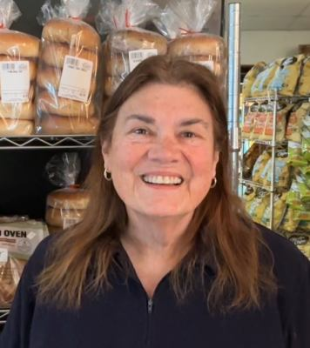

It’s hard to believe that it’s almost Easter. After the winter we had, everyone is looking forward to warmer temps and getting out in the yard. (At least I sure am) I hope you’ll put the Holy Week services including the Sunrise service on your schedule and you have a glorious day celebrating our risen savior. We have some exciting months ahead with banquets, concerts, special services, BBQ’s, Bible Studies, Pot Lucks, Graduation celebrations and so much more. We have a lot to offer so why not ask a friend, family member or neighbor to join us for service on Sunday morning.
That’s all for this month. I’ll see you on Sunday morning.
Donna

United Methodist Women



The ladies met after church on March 8th for our monthly meeting with 14 ladies in attendance. Donna Reen joined us as a new member. Minutes were not available for review from the last meeting. Sue Tobin requested that someone else take over the job of recording secretary and Donna Reen volunteered. The Treasurers Report reported that the Soup Sale profits were $758 minus the cost of the fees for using the Square for credit card sales. $500 will be donated to Friendship Star Quilters for the purchase of batting. Under New Business there was discussion about our responsibility for Easter Sunday. Carol M will pick up the donuts. Donna R will get the coffee and hot chocolate. The daffodil cross may be difficult to achieve as the daffodils may be done blooming by Easter Sunday. We will reevaluate on Palm Sunday. Sue Tobin asked she will pick up the Palms for Palm Sunday. Next order of business was the Women of Hope Banquet coming up May 7. Pastor Robing confirmed the caterer will require a deposit to secure the date. Trish C volunteered to be the contact for ticket reservations and everyone will pitch in to coordinate the silent auction. There was much discussion about the beneficiary of the banquet and it was decided and voted on for Grateful Acres. Trish C volunteered to create the flyers and Sue T and Carol M will do the decorations. The meeting was adjourned and we will meet again after service on April 12th.
This Photo by Unknown Author is licensed under CC BY
Donna Cavender, President


Happy Birthday to…
Carol McGlotghlin…………April 4
Sue Tobin………….………..April 13
Matthew Carrico….………April 20
Please let me know your birthday or anniversary so I can share it with our church family and we will celebrate with you.

Men’s Bible Study - Don’t forget to join the men’s Bible Study on Thursday mornings from 10am to noon. The men are studying the book of Genesis.
Women’s Bible Study - Women's Bible Study is every Wednesday morning. The ladies will be studying the book “Secrets of the Vine: Breaking Through to Abundance” by Bruce Wilkinson.
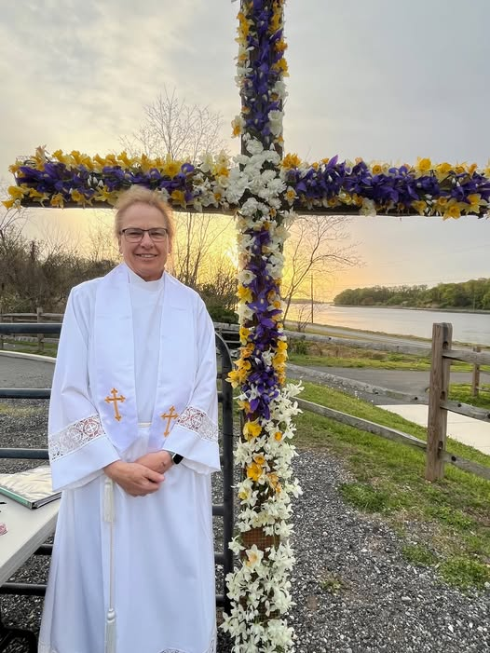
Our Pastor: Rev Robin Hurley
Office Hours: Tuesday, Wednesday and Thursday
My phone number: 302-270-8942
My e-mail: pastorrobinh@gmail.com


Sympathy Card
This Photo by Unknown Author is licensed under CC BY-NC-ND
The Babington’s (Jaswant’s mother has passed)
1107 Casey Dr,
New Castle, DE 19720

You are looking for Jesus the Nazarene, who was crucified. He is risen! He is not here. Mark 16:6

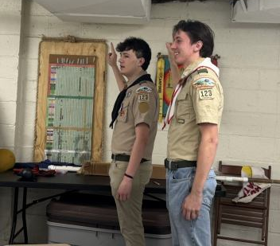
Scout Update
Eagle Scouts, Kyle Gessner and Garrett Borntregar, visit Troop 123, while home for Spring break.

“Blessed is the one who trusts in the Lord.” – Jeremiah 17:7

Care Cards
Members of our congregation who are in need of our love and encouragement include…

Chip Cavender
224 Ratledge Rd
Townsend, DE 19734

Earl Jaques
82 Cann Rd
Newark, DE 19702


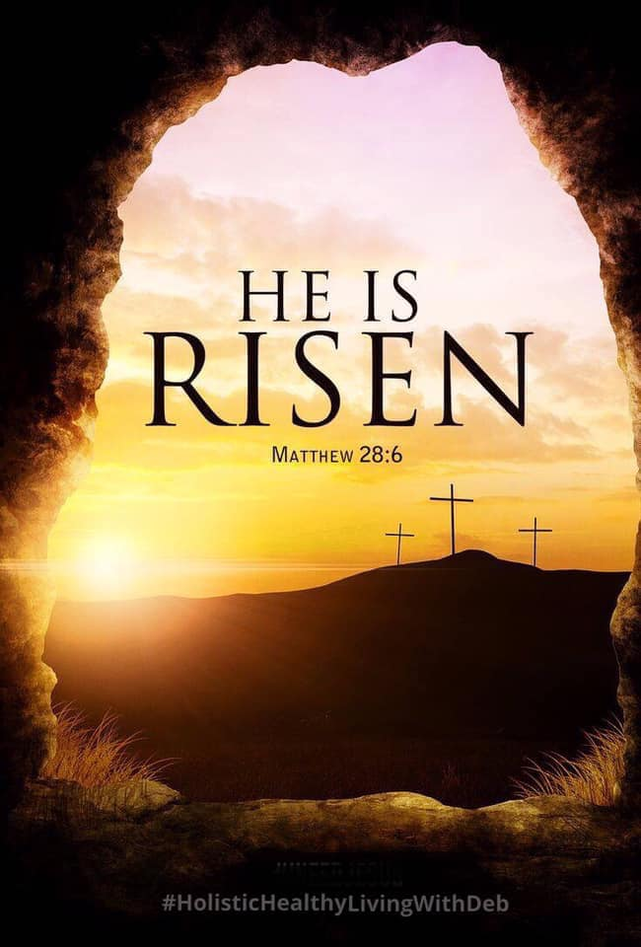

Our Pastor
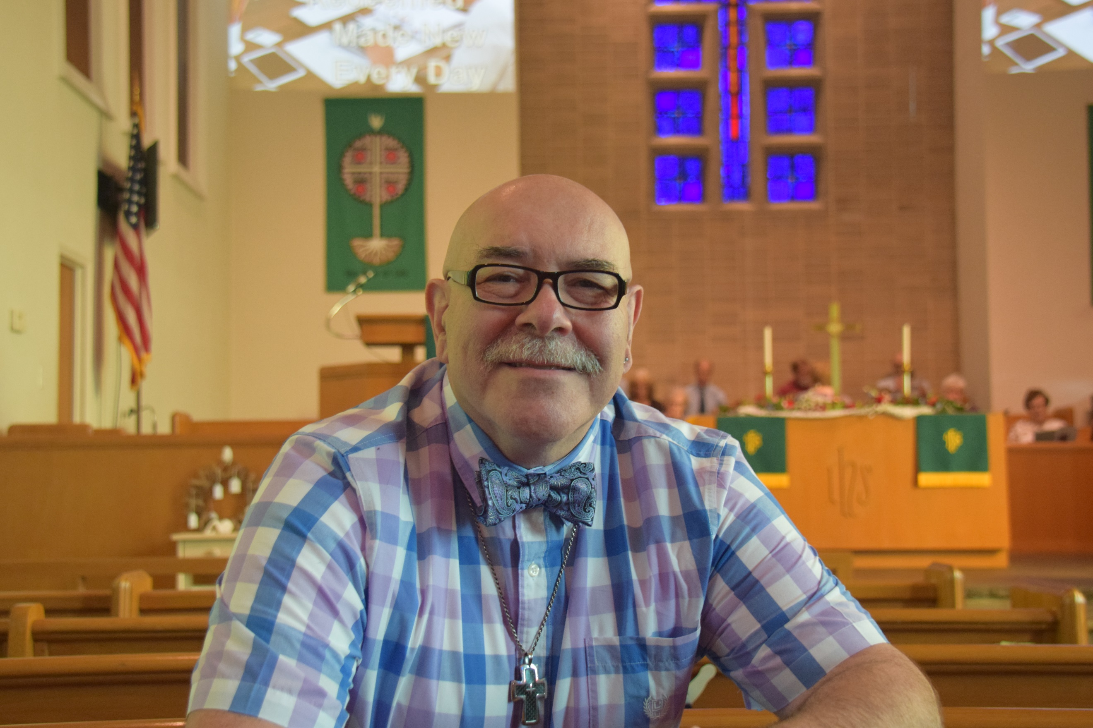
Rev. Asher F. Tunik

Phone: 443-350-5077
e-mail: pastorasher@gmail.com

Office Hours:
• By Appointment
• On Friday mornings

Available to meet
with individuals:

• Via Phone
• Via ZOOM
• By Appointment
St Georges United Methodist Church
P.O. Box 145
St. Georges, DE 19733



Dates to Remember
April 2……….Maundy Thursday Service 6pm
April 3……….Good Friday Service 6pm
April 5………Easter Sunday Sunrise Service 6:45am
April 5………Easter Sunday Service 10am
April 12……..Ladies Meeting after service

He Is Risen!!!!!!!!!!!!!

